E-Commerce Application
Project Structure:
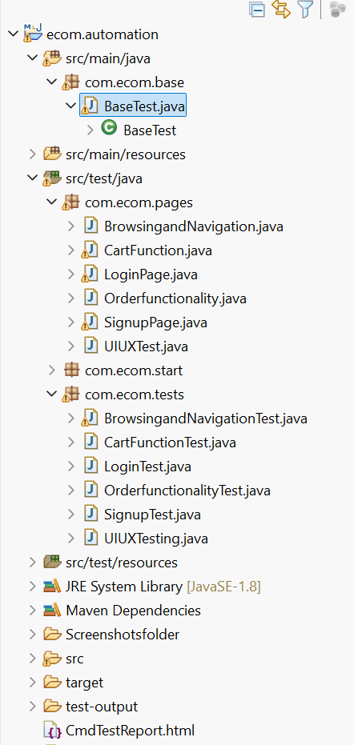

Src/main/java/com.ecom.base
BaseTest.java:
package com.ecom.base;

import java.io.File;
import java.io.IOException;
import java.time.Duration;

import org.apache.commons.io.FileUtils;
import org.openqa.selenium.By;
import org.openqa.selenium.OutputType;
import org.openqa.selenium.TakesScreenshot;
import org.openqa.selenium.WebDriver;
import org.openqa.selenium.WebElement;
import org.openqa.selenium.chrome.ChromeDriver;
import org.openqa.selenium.edge.EdgeDriver;
import org.openqa.selenium.firefox.FirefoxDriver;
import org.openqa.selenium.interactions.Actions;
import org.openqa.selenium.safari.SafariDriver;
import org.openqa.selenium.support.ui.ExpectedConditions;
import org.openqa.selenium.support.ui.WebDriverWait;

import com.aventstack.extentreports.ExtentReports;
import com.aventstack.extentreports.ExtentTest;
import com.aventstack.extentreports.reporter.ExtentSparkReporter;

public class BaseTest {

public static WebDriver driver=null;
public static ExtentSparkReporter reporter;
public static ExtentReports report = null;
public static ExtentTest test = null;
public static WebDriverWait wait;

public static void getReport() {
reporter = new ExtentSparkReporter(System.getProperty("user.dir") + "/CmdTestReport.html");
report = new ExtentReports();
report.attachReporter(reporter);

}

public static void startbrowser(String browser) {

switch(browser) {
case"chrome":
driver= new ChromeDriver();
break;
case"firefox":
driver = new FirefoxDriver();
break;
case"edge":
driver = new EdgeDriver();
break;
case "safari":
driver = new SafariDriver();
break;
default:
driver= new ChromeDriver();
}
driver.manage().window().maximize();

}

public static void closebrowser() {
driver.quit();
}

public void wait(WebElement element) {
wait = new WebDriverWait(driver, Duration.ofSeconds(10)) ;
wait.until(ExpectedConditions.visibilityOf(element));
}

public void click (WebElement element) {
try {
Thread.sleep(2000);
} catch (InterruptedException e) {
// TODO Auto-generated catch block
e.printStackTrace();
}
wait.until(ExpectedConditions.visibilityOf(element));
Actions action = new Actions(driver);
action.moveToElement(element).click().perform();

}

public static void ElementSendKeys (WebElement element,String Value) {
element.clear();
element.sendKeys(Value);
}

public static String ElementGetText (WebElement element) {
String value ="";
value = element.getText();
return value;
}

public static void Feedinput(WebElement element, String value) {
WebDriverWait wait = new WebDriverWait(driver, Duration.ofSeconds(10));
wait.until(ExpectedConditions.visibilityOf(element));
element.sendKeys(value);
}
public String getalertmsg() {
WebDriverWait wait = new WebDriverWait(driver, Duration.ofSeconds(10));
wait.until(ExpectedConditions.alertIsPresent());
String txt =driver.switchTo().alert().getText();
return txt;
}
public void acceptalert() {
WebDriverWait wait = new WebDriverWait(driver, Duration.ofSeconds(10));
wait.until(ExpectedConditions.alertIsPresent());
driver.switchTo().alert().accept();
}

public static String captureScreenshot(String testName) {
TakesScreenshot ts =(TakesScreenshot)driver;
File src=ts.getScreenshotAs(OutputType.FILE);
String destPath = System.getProperty("user.dir")+"/Screenshotsfolder/"+testName+".png";
try {
FileUtils.copyFile(src, new File(destPath));
} catch (IOException e) {
// TODO Auto-generated catch block
e.printStackTrace();
}
return destPath;
}
}

Src/test/java/com.ecom.start
Start.java
package com.ecom.start;

import org.testng.annotations.AfterMethod;
import org.testng.annotations.AfterSuite;
import org.testng.annotations.BeforeMethod;
import org.testng.annotations.BeforeSuite;

import com.ecom.base.BaseTest;

public class Start extends BaseTest{
@BeforeSuite
public void beforesuite() {
getReport();
}

@AfterSuite
public void aftersuite() {
report.flush();
//closebrowser();
}

@BeforeMethod()
public void beforemethod() {
startbrowser("chrome");
driver.get("https://www.demoblaze.com/");
}

@AfterMethod()
public void aftermethod() {

}
}

Testng Xml Code:
<?xml version="1.0" encoding="UTF-8"?>
<!DOCTYPE suite SYSTEM "https://testng.org/testng-1.0.dtd">
<suite name="Suite">
<test thread-count="5" name="Test">
<classes>
<class name="com.ecom.tests.SignupTest"/>
<class name="com.ecom.tests.LoginTest"/>
<class name="com.ecom.tests.CartFunctionTest"/>
<class name="com.ecom.tests.OrderfunctionalityTest"/>
<class name="com.ecom.tests.BrowsingandNavigationTest"/>
<class name="com.ecom.tests.UIUXTesting"/>
</classes>
</test> <!-- Test -->
</suite> <!-- Suite -->

